Understanding the global freshwater system by combining geodetic and remote sensing information with modelling using a calibration/data assimilation approach

Jürgen Kusche (University of Bonn), Petra Döll (University of Frankfurt), Olga Engels (University of Bonn), Laura Foglia (UC Davis), Andreas Güntner (GFZ Potsdam), Annette Eicker (HCU Hamburg), Laurent Longuevergne (Univ. Rennes), Denise Dettmering (DGFI Munich), Nico Sneeuw (University of Stuttgart), Mohamad Tourian (University of Stuttgart), Claudia Künzer (DLR), Ursula Geßner (DLR), Tobias Bolch (University of St. Andrews), Tonie van Dam (University of Luxembourg)

http://globalcda.de/

Objectives

The GlobaCDA projects seeks to develop a reanalysis of the global freshwater system by combining geodetic and remote sensing information with modelling using a calibration/data assimilation approach; this will include SWOT data as well as GRACE, GRACE-FO, other radar altimetry data and data from several other remote sensing satellite missions. The GlobalCDA project is currently funded by the German Research Foundation DFG as Research Unit (RU) FOR2630. It is coordinated by Petra Döll and Jürgen Kusche.
Contemporary global hydrological and land surface models provide conflicting estimates of e.g., mean annual evapotranspiration or low, mean, and high flows in river basins, resulting in strongly differing estimates of current water availability or of climate change impacts on freshwater resources. It is thus our central objective to improve our understanding of global freshwater resources and to obtain better estimates of continental water fluxes (streamflow, groundwater recharge, actual evapotranspiration, and renewable water resources) and storages (in snow, soil, groundwater and surface water bodies as well as in glaciers). We believe that a major improvement can only be achieved through combining state-of-the-art hydrological modelling and multiple new and optimally processed geodetic and remote sensing data in an ensemble-based calibration and data assimilation (C/DA) approach that allows a flexible parameter (calibration) and state (data assimilation).
Such an approach, which would additionally take into account uncertainty due to model structure, has not been implemented yet. Our main goals are thus (1) develop a multi-observation ensemble-based C/DA methodology to combine observational data of model output variables (time series of gauge-based streamflow and GRACE and GRACE-FO total water storage variations as well as remotely-sensed data on extent and water level of surface water bodies, snow cover, glacier mass change and streamflow) with hydrological models in an optimal manner, and (2) exploit this methodology with the global hydrological model WaterGAP to provide an improved quantitative assessment of freshwater fluxes and storages including their uncertainties in response to climate and anthropogenic forcing, in the first phase focusing on six regions. The C/DA approach will encompass an Ensemble Kalman Filter approach (EnCDA) for both data assimilation and calibration (but very challenging regarding calibration) and a Pareto-optimal calibration approach (POC) that is known to enable optimization of temporally constant parameters. Sensitivity analyses, uncertainty information provided by C/DA as well as model validation against independent data will allow evaluating the added value of applying the C/DA approach.
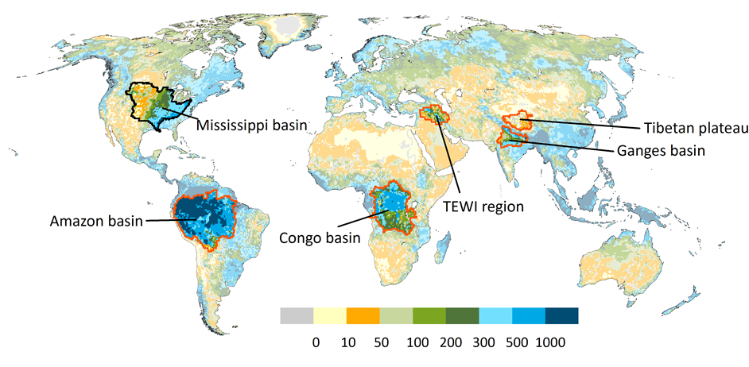

Fig. 1: Focus regions.

Methods
The RU will implement a fresh research setup centred on C/DA that will, for the first time, enable full utilization of geodetic and remote sensing observations of model output variables for global water assessments. Data assimilation for global water resources modelling has never been done so far, and exploitation of so many remote sensing and geodetic data would be entirely new as well, even regarding calibration. C/DA facilitates data and knowledge integration, bringing together hydrologists with expertise in process knowledge and modelling and geodesists/remote sensing specialists with expertise in spaceborne measurements of water storage and fluxes. This integration will lay the foundation for sustained research that aims at continuously improving the quantification of freshwater dynamics including their uncertainties as well as at the integration of new Earth observation data.
The RU is organized in five work blocks:
(1) Development of a calibration/data assimilation approach for integrating multiple satellite data sets into the global WaterGAP hydrological model, point of departure are the EnKF approach developed at U Bonn and the Pareto-optimal model calibration approach developed at GFZ Potsdam. Methods need to allow for sensitivity analysis, parameter calibration at different spatial scales and use of different observation data types and criteria.
(2) Hydrological model development. In this WB, new WaterGAP model components and algorithms will be developed and/or implemented and assessed. A focus in will be on replacing the storage-based algorithm for representing groundwater flows and storage by integrating a hydraulic head gradient-based groundwater model into WaterGAP. This is particularly important for simulation of water fluxes between groundwater and surface water bodies, where with the current algorithm no dynamic simulation of losing surface water bodies including rivers is possible.
(3) Development and provision of observational data for model calibration and data assimilation and validation. This involves gauge-based river discharge, surface water height, GRACE temporal gravity, mountain glacier extent, MODIS-based water and snow covered areas, GNSS-derived 3D station displacement time series, multi-mission intercalibrated river elevation data, discharge information from altimetry, surface water extent data, snow cover data, mountain glacier mass change from differencing of TanDEM-X/ASTER DEMs with the SRTM DEM differencing and ICEsat and forthcoming ICESat-2 altimetry. In the second phase of GlobalCDA, data from new satellite missions (GRACE-FO, SWOT, Sentinel 1-C and 3-C) will be incorporated.
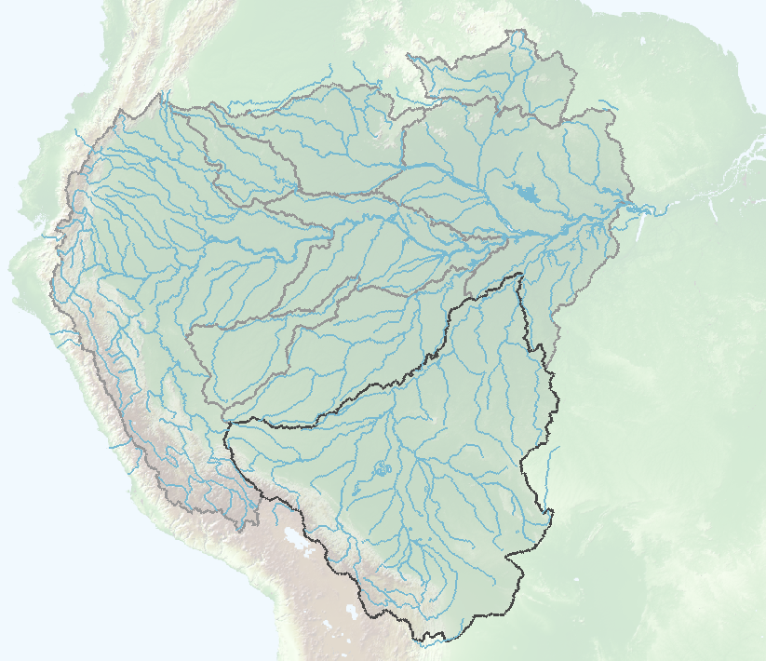
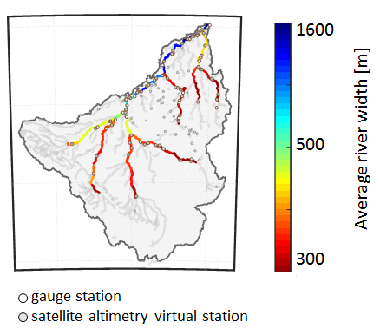
Average river width [m]

Fig 2: The number of active gauges for discharge monitoring along rivers decreases. Spaceborne geodetic techniques enable us to overcome the lack of comprehensive measurements of freshwater resources. However we are not still able to estimate discharge accurately at any point of the river network with optimal temporal resolution. Simultaneous river height, width and slope measurements of the SWOT mission will provide the opportunity to have a better understanding of the dynamic of the river discharge for the whole river network.

(4) Validation, characterization of model output uncertainty and evaluation of the calibration and data assimilation approach. We will explore the use of new data sets and methods for independent and rigorous validation of output of a number of variants of the calibrated/assimilated WaterGAP model (WB1-WB3), mainly at the regional scale. Beyond the more common validation tests (leaving subsets of data out, benchmark studies), we will perform extensive validation against independent data.

Preliminary Results

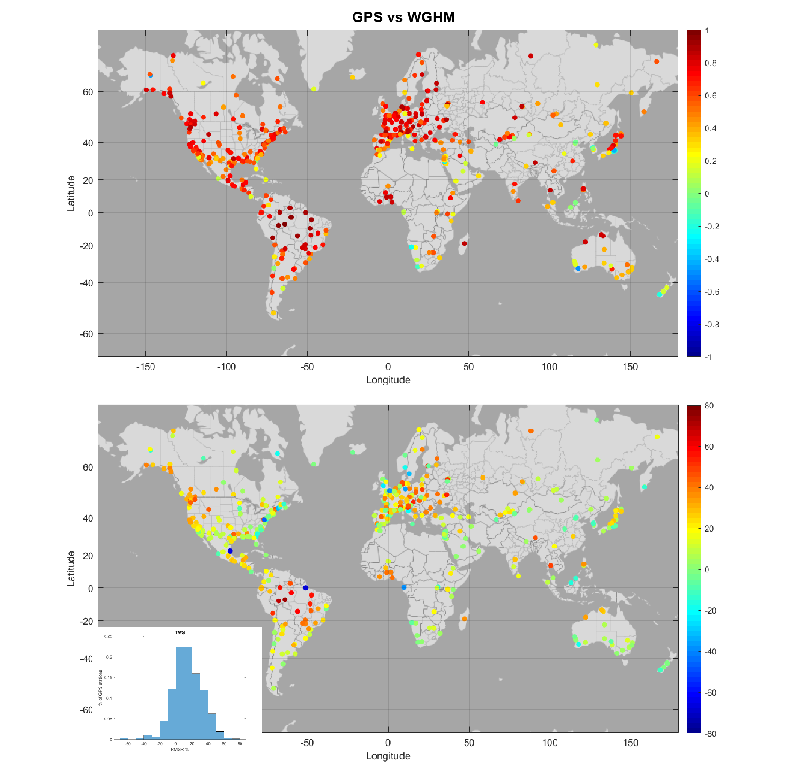
Fig 3. Correlations (top) and RMS reduction (RMSR) ratio (bottom) between GNSS-observed vertical motion from the ITRF2014 solutions and the WGHM derived displacement in the vertical direction.

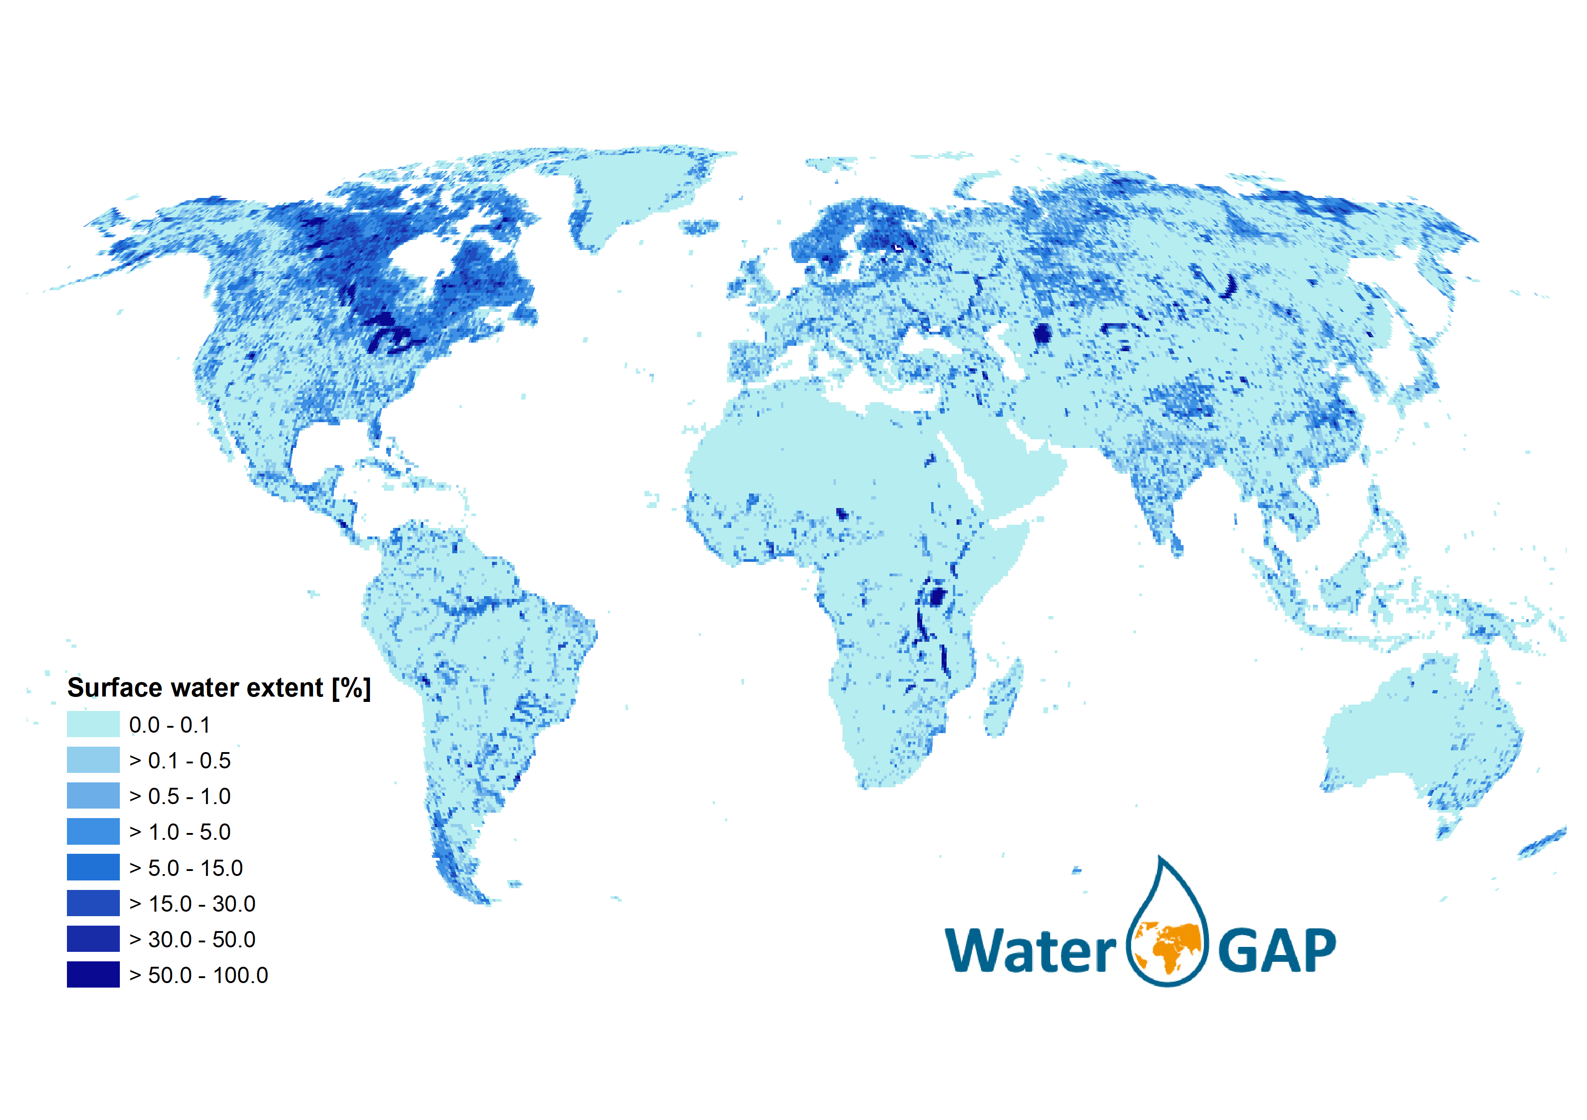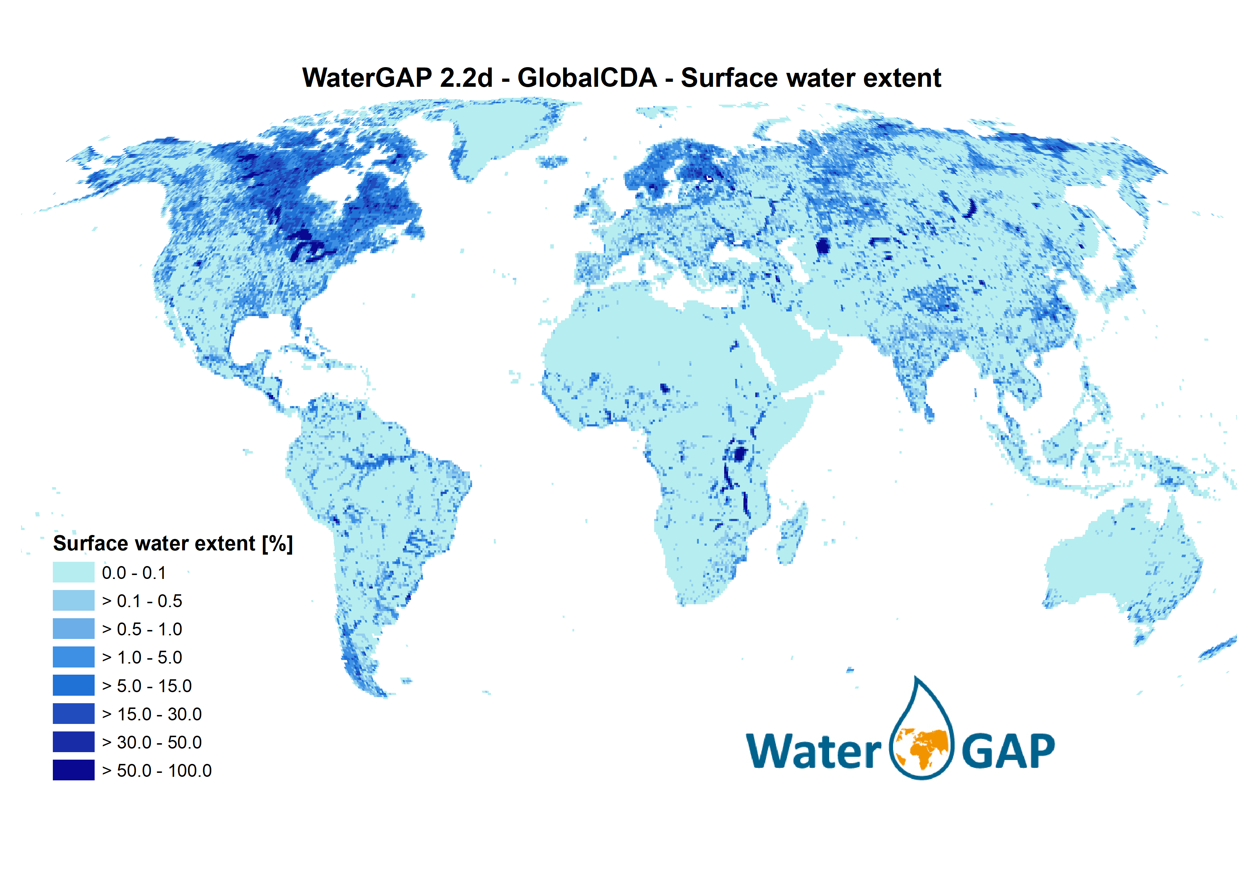
Fig. 4. This map represents the map-derived maximal surface water areas that serve as basis for WaterGAP 2.2d dynamic surface water extent and volume calculations. SWOT can inform better about the relation between surface water area and volume.

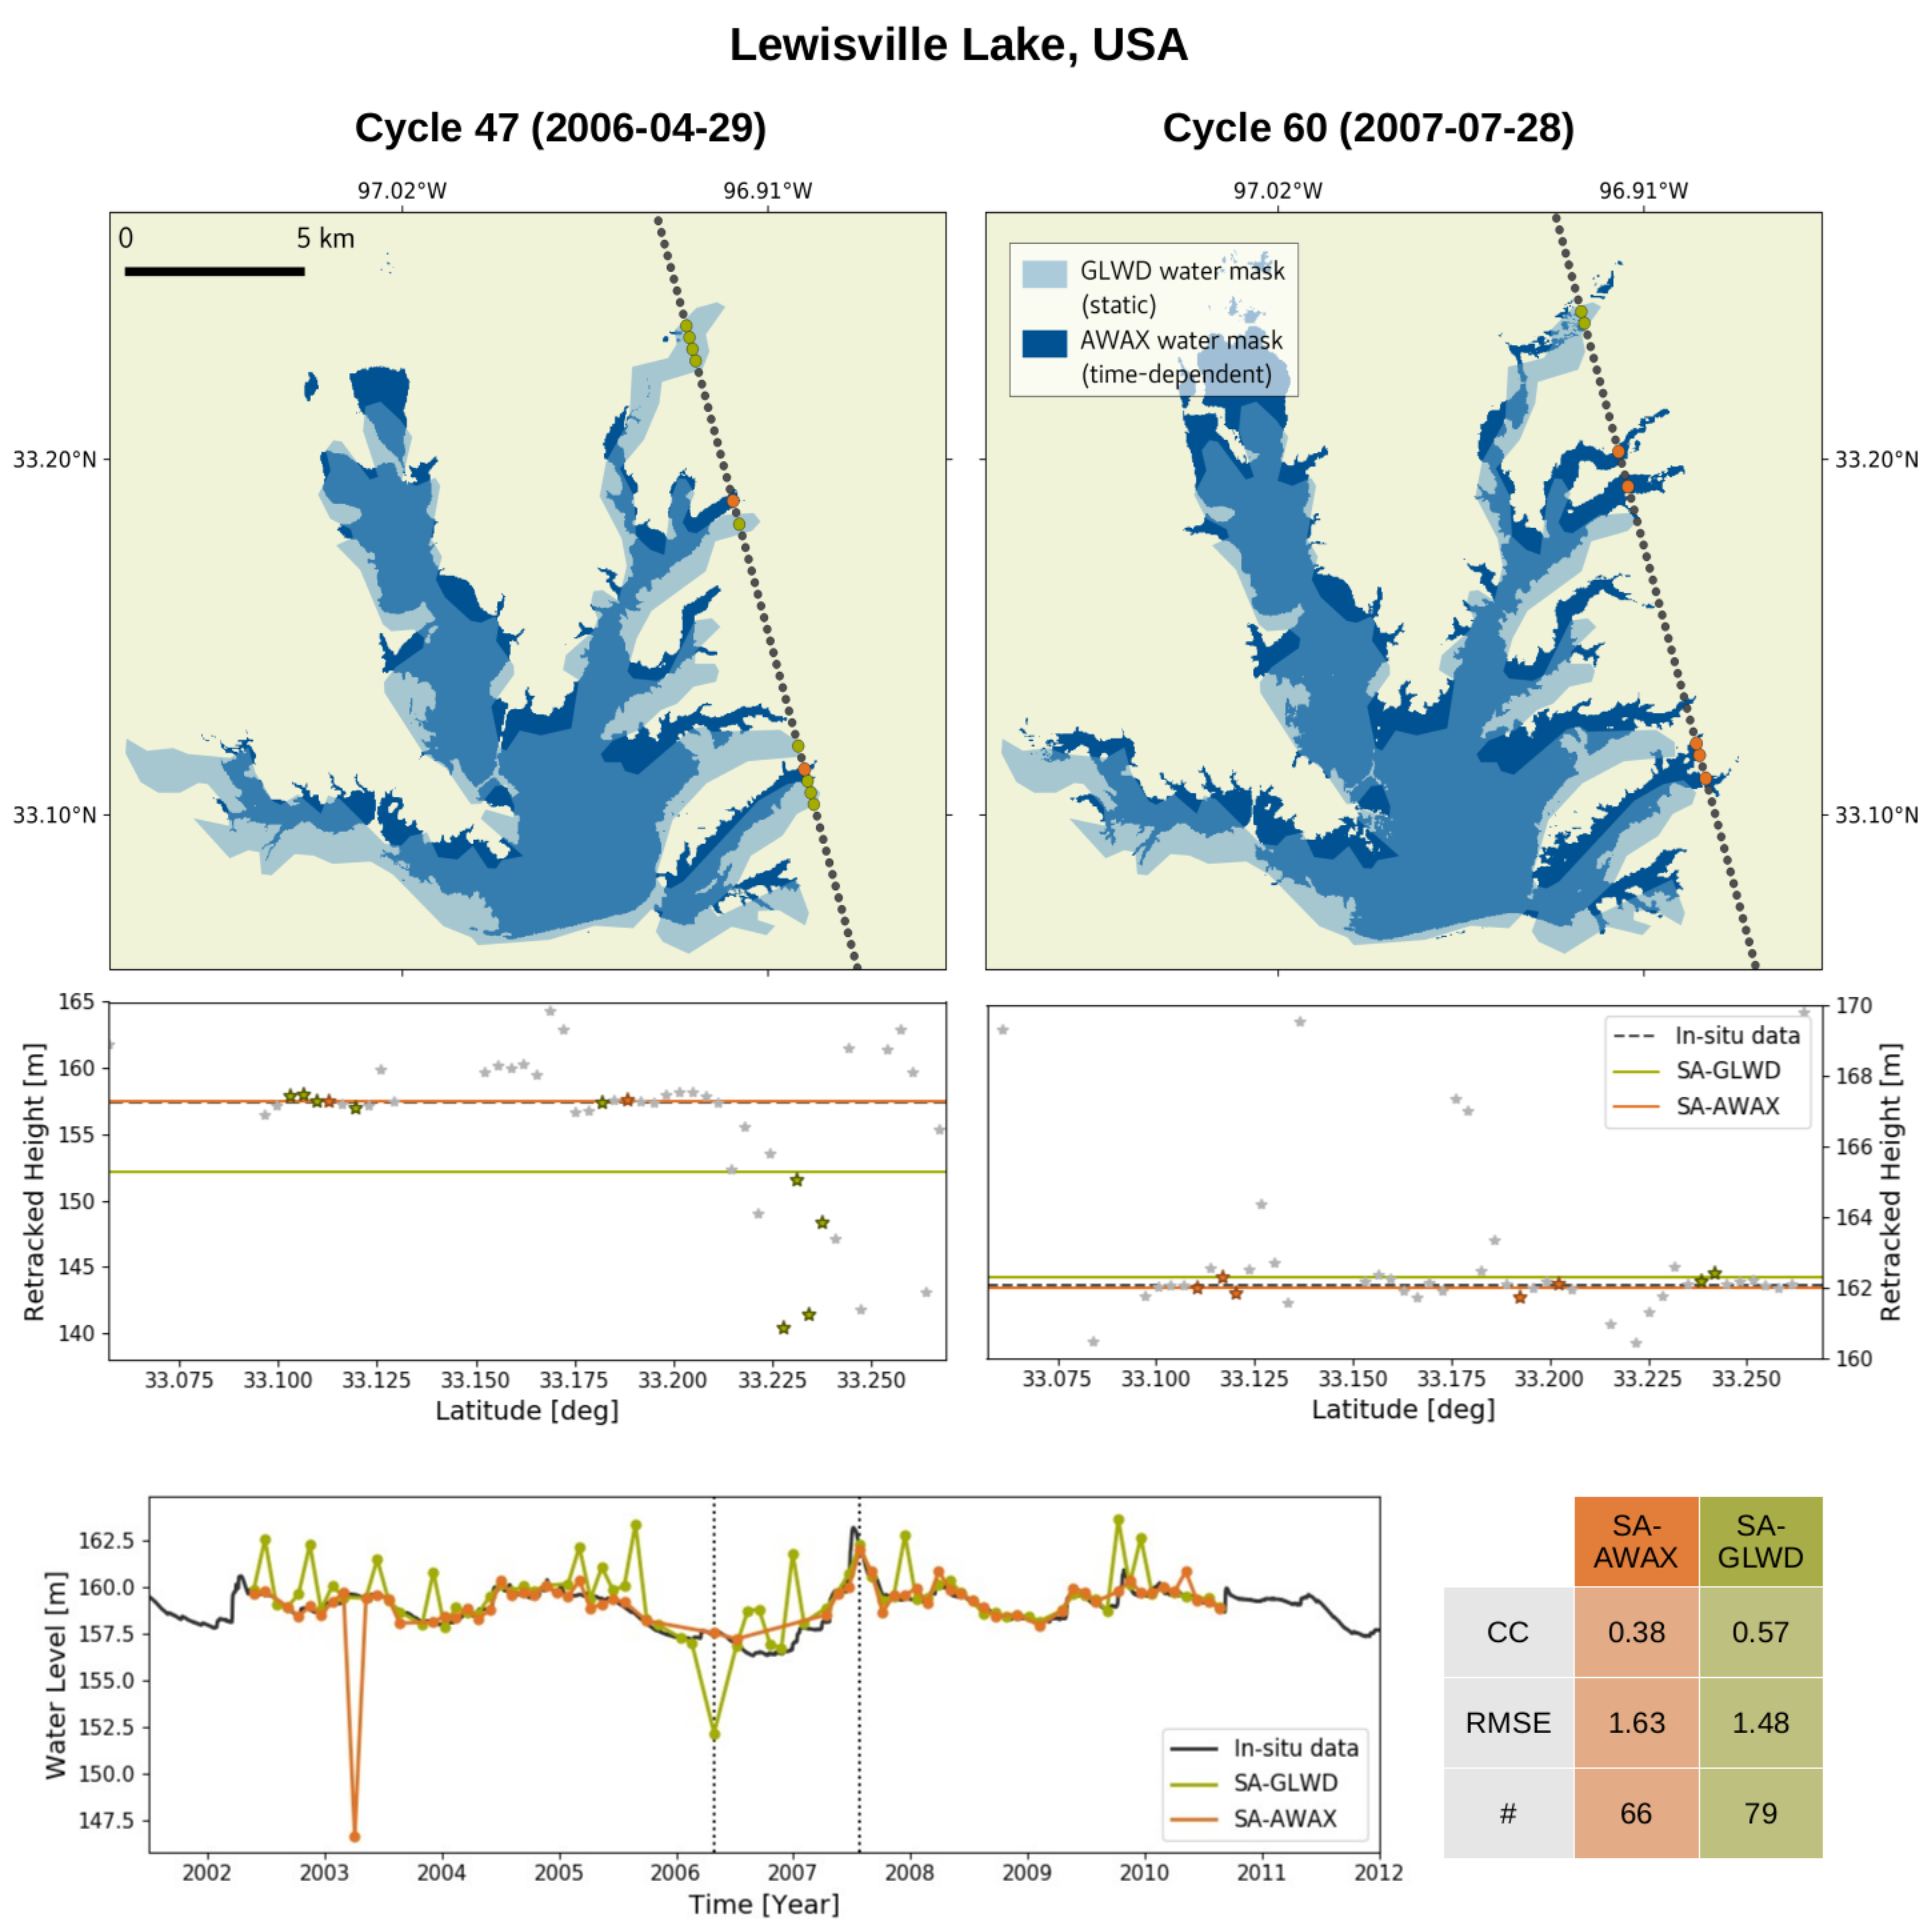

Fig 5. Water level time series from satellite altimetry are improved by an extended outlier detection using time-dependent water masks.

Fig 6. GRACE TWSA observations (left), model simulation (right) and data assimilation (center).

Expected Results
GlobalCDA aims at a comprehensive reanalysis of water storage in lakes, rivers, other surface water bodies including floodplains, as well as groundwater and other subsurface compartments. It aim as regional scale in its first phase (2016-2019) and at global scale in its second phase (2020-2022). It aims at developing methods and tools for the combination of various data sources including SWOT as well as the assimilation of these data sets into global hydrological models.

References

Döll, P., Douville, H., Güntner, A., Müller Schmied, H., Wada, Y. (2016): Modelling freshwater resources at the global scale: Challenges and prospects. Surveys in Geophysics, 37(2), 195-221. doi: 10.1007/s10712-015-9343-1

Eicker, A., Schumacher, M., Kusche, J., Döll, P., Müller Schmied, H. (2014): Calibration/Data Assimilation Approach for Integrating GRACE Data into the WaterGAP Global Hydrology Model (WGHM) Using an Ensemble Kalman Filter: First Results, Surveys in Geophysics, 35(6): 1285-1309

Klein, I., Dietz, A., Gessner, U., Dech, S., Kuenzer, C. (2015): Results of the Global WaterPack: a novel product to assess inland water body dynamics on a daily basis. Remote Sensing Letters, Vol. 6, No. 1, 78-87

Müller Schmied, H., Eisner, S., Franz, D., Wattenbach, M., Portmann, F. T., Flörke, M., Döll, P. (2014): Sensitivity of simulated global-scale freshwater fluxes and storages to input data, hydrological model structure, human water use and calibration, Hydrological and Earth System Sciences, 18, 3511-3538

Riegger, J., Tourian, M. J. (2014): Characterization of runoff-storage relationships by satellite gravimetry and remote sensing, Water Resources Research, doi: 10.1002/2013WR013847.

Schumacher, M., Kusche, J., Döll, P. (2016): A systematic impact assessment of GRACE error correlation on data assimilation in hydrological models , Journal of Geodesy, (online first) 10.1007/s00190-016-0892-y

