Estimation of River Discharges from SWOT Observations using Variational Data Assimilation and Saint-Venant Hydraulic Models

SWOT DAHM
Hind Oubanas, Pierre-Olivier Malaterre, Igor Gejadze

SWOT Science Team Members:
Hind OUBANAS
Principal Investigator at INRAE

Research Scientist in Data Assimilation and Inverse Problems

Email: hind.oubanas@inrae.fr
Phone: (+33) 4 67 16 65 08
Mobile: (+33) 6 68 42 54 50
Address: 361 Rue Jean François Breton - B.P. 5095 34196 Montpellier Cedex 5, France

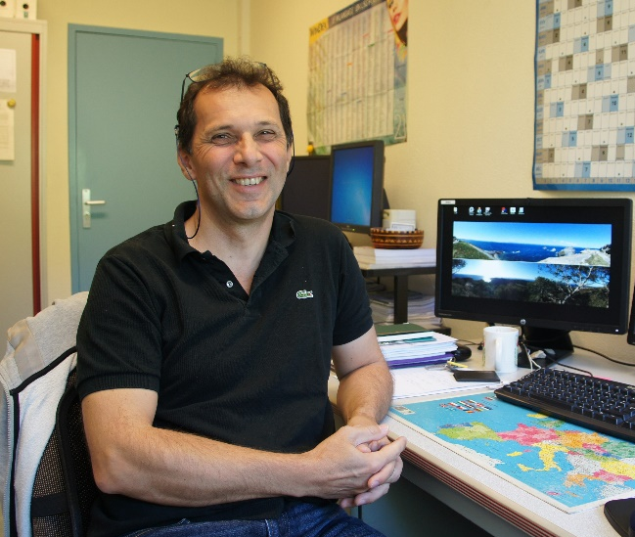
Pierre-Olivier MALATERRE

Researcher in Hydraulic Modeling, Hydroinformatics and Automatic Control

Email: pierre-olivier.malaterre@inrae.fr
Phone: (+33) 4 67 04 63 56
Mobile: (+33) 6 51 74 75 87
Address: 361 Rue Jean François Breton - B.P. 5095 34196 Montpellier Cedex 5, France

Involved INRAE Members:
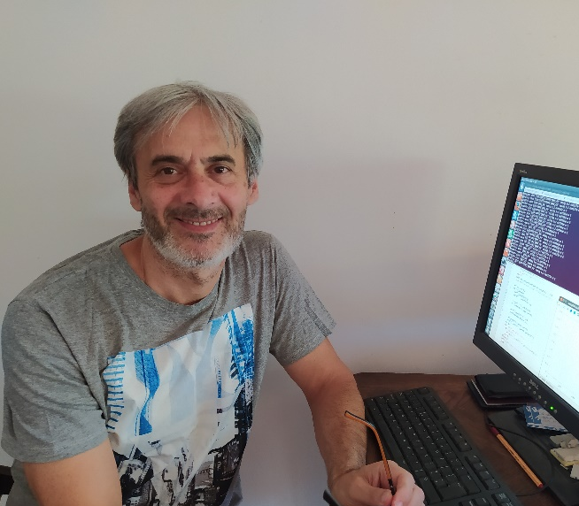
Igor GEJADZE

Research Director in Optimal Control Theory and Uncertainty Quantification

Email: igor.gejadze@inrae.fr
Phone: (+33) 4 67 16 64 08
Address: 361 Rue Jean François Breton - B.P. 5095 34196 Montpellier Cedex 5, France

Introduction & Context
The multidisciplinary research team GHOSTE (Gestion Hydraulique, Optimisation et Supervision des Transferts d'Eau) is part of the UMR G-eau (Unité Mixte de Recherche sur la Gestion de l'Eau, de ses Acteurs et de ses Usages), located at INRAE, Montpellier, France. The team research is focused on the free surface hydraulic systems, including irrigation canals, and rivers. The GHOSTE team gathers more than 30 years of expertise in various scientific disciplines, mainly hydraulic and hydrology, optimization, control and data assimilation (DA). It is formed by researchers, engineers, PhD students and technicians that participate actively in the development of simulation software, such as the in-house software SIC² (Simulation Intégrée des Canaux et de leur Contrôle, http://sic.g-eau.net). One of our major present activities lies in the field of spatial hydraulics/hydrology, which aims at improving the knowledge of the world’s rivers through the optimal use of satellite data in a hydraulic network model. Thus, several DA methods have been implemented with SIC² since early 90’s: Kalman Filtering, Particle Filtering, and 4D-Var.

The team has been involved in the SWOT mission project since 2015 and is currently participating in the SWOT Discharge Algorithms Working Group (SWOT DAWG), which is developing the algorithms to estimate the discharge in the form of the official SWOT discharge product, at the global scale. The proposed algorithms offer different levels of complexity in the representation of the hydraulic dynamics and the optimization methods that are involved, resulting in different levels of accuracy, scale of applicability and the required computational resources. A first version of INRAE’s discharge algorithm has been proposed (Oubanas et al. 2018a,b, Gejadze and Malaterre 2017) based on a full Saint-Venant hydraulic model and variational data assimilation. For an accurate estimation of discharge, an information about the river’s topography/bathymetry is necessary, but rarely available. Different approaches have been developed in previous works to approximate the bathymetry from simulated SWOT observations and the globally available ancillary data from global hydrological models (Water Balance Model). Although those methods provide a satisfactory estimation of the bathymetry, they may require long enough temporal series of data to be processed before real-time discharge calculation. In this respect, time series of water elevation and width issued from different satellite missions or ancillary databases will be combined. Moreover, globally available auxiliary information is to be considered as well, such as outputs of global hydrological models that simulate the prior information of discharge at the sub-basin scale from hydro-meteorological observations (rainfall, evapotranspiration, humidity, etc.).

Objectives and Methodology

In the context of the TOSCA-ROSES calls, INRAE, in collaboration with Cerfacs (Toulouse, France), will further develop and improve methodologies and techniques for river discharge estimation from SWOT data using advanced hydraulic models and data assimilation procedures to achieve the best possible accuracy. The main objectives of INRAE involve a set of scientific and technical issues to be solved for the “key pre-launch preparations, post-launch calibration and validation, and initial scientific exploitation”. This includes the following aspects:

- Background/Prior Bathymetry generation:
The existing methodology for bathymetry estimation (Oubanas et al. 2018b) provides a reasonably good estimation of bathymetry, but needs data over an entire hydrology cycle observed by SWOT. In order to prepare for the SWOT mission, we suggest a novel approach to estimate river bathymetry, using data from existing and/or past satellite missions that will be later updated using the forthcoming SWOT observations. The purpose is to create a global database of the bathymetry product based on multi-sources data.
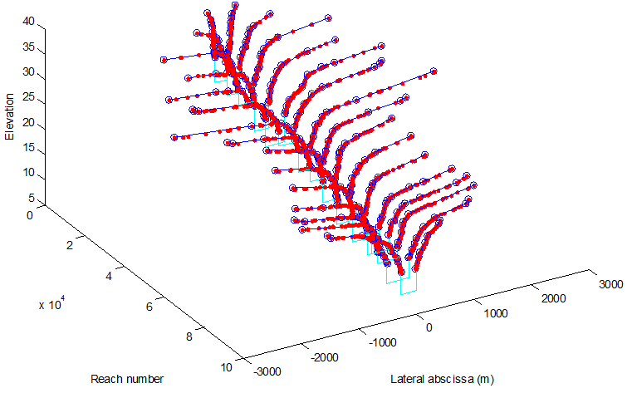
Figure 1: Po River bathymetry using the SWOT simulated observations. Red part: the dry bathymetry and cyan: the wet bathymetry
- Multi-Mission Data Assimilation “analysis”
The proposed SIC4DVAR algorithm combines the 1.5D hydraulic model SIC² and a variant of the Four Dimensional Variational data assimilation method (4D-Var). It allows solving the inverse problem of discharge estimation under uncertainties in bathymetry and friction. Given the priors of the upstream discharge, bathymetry and roughness, SIC4DVAR assimilates all observations available within the assimilation window and performs simultaneous estimation of the variables of interest {Q, Zb, Ks} via minimization of a well-defined cost function. The latter is re-formulated for the iterative regularization approach based on early termination of the minimization procedure to avoid assimilation of high frequencies in signal (noise in the data). The cost function is minimized based on its gradient using the limited-memory Quasi-Newton (Broyden–Fletcher–Goldfarb–Shanno algorithm) method. Moreover, the algorithm uses a sequential version of 4D-Var method that operates by sliding temporal sub-windows, which allows its application to a very long study period (several years) without requiring additional computational resources. Figures 6 and 7 illustrate two cases, the Po River with a temporal frequency high enough to recover the dynamics of the system and the Sacramento River with very low observation frequency, which prevents from accurate estimation of discharge. These examples emphasize the importance of using data from multiple sources including in-situ, satellite and interpolated and extrapolated observations.
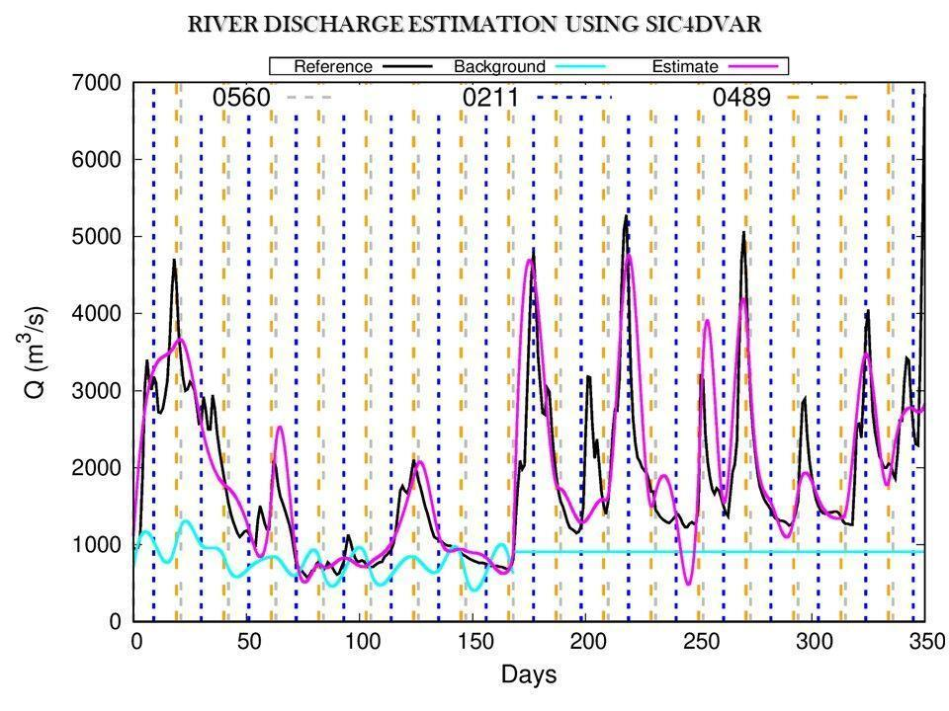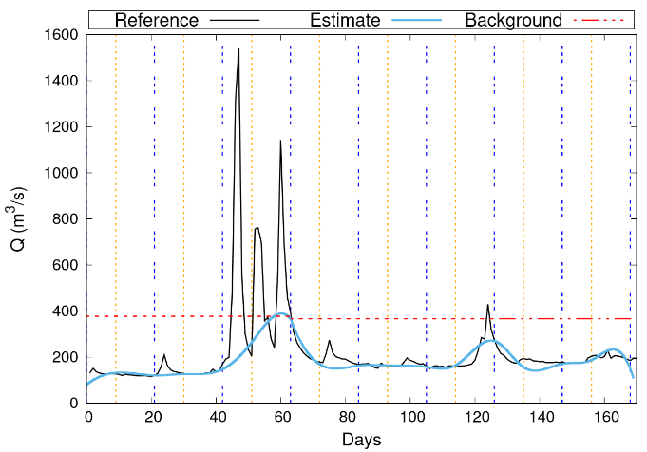
Figure 2: Discharge estimation over the (left) Po River and (right) Sacramento River from SWOT simulations. Vertical lines indicate the observation time and different colors are associated to different passes of SWOT.

- Performance estimation and validation
The aim of the SWOT DAWG is to provide discharge algorithms that could be applied at the global scale in gauged and ungauged basins. However, the hydraulic behavior varies significantly from one river to another and depends on the characteristics of the basin and the interactions with the ocean and atmosphere. Therefore, it is very challenging to design a generic algorithm capable of handling all types of river dynamics. The DAWG has designed an experimental set up for an inter-comparison of discharge algorithms. The proposed benchmark involves rivers of different hydraulic behavior defined based on the following river characteristics: morphology, seasonality, hydraulic regime, geometry, width, management, floodplain-channel interactions. The proposed benchmark is divided into two experimental setups with two distinct datasets and several phases and sub-phases that allow testing the impact of several factors separately.
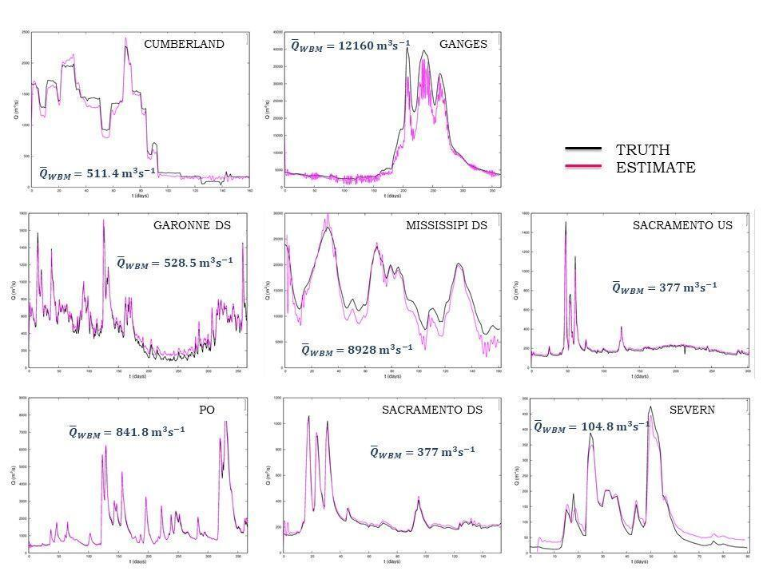
Figure 3: Discharge estimation using SIC4DVAR on the Pepsi Challenge 1.

- Calibration/Validation Application
Among the CAL/VAL sites, the Mahanadi River (India) and the Maroni River (French Guyana) will be observed. These sites will be studied in the framework of a collaboration between INRAE, LEGOS, the Indian Space Research Organization and the Indian Institute of Technology of Bombay. Objectives include: 1) the processing of altimetry data from satellites that observe both sites, 2) generation of the SWOT simulations using the SWOT hydrology simulators developed by NASA JPL and CNES. 3) Planned fieldwork to collect in-situ observation for the validation of the obtained results. 4) Assimilation of the SWOT daily observations during the calibration period and validation against the collected in-situ data. 5) Comparison with the SWOT nominal phase.

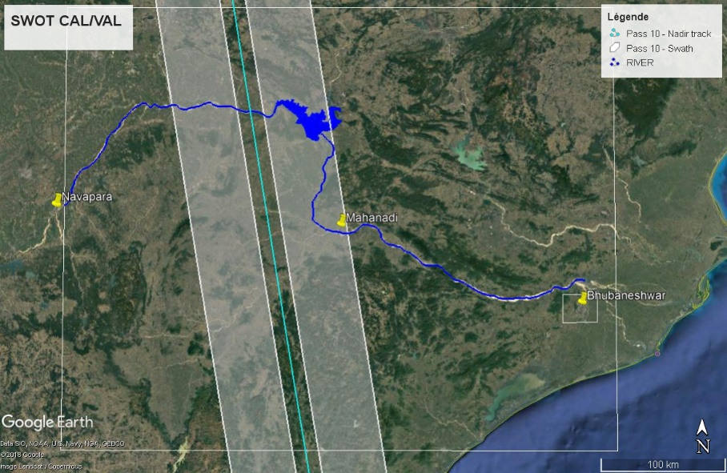
Figure 4: The Mahanadi River SWOT CAL/VAL.

References
Andral Alice, Sébastien Legrand, Jean-François Cretaux, Stéphane Calmant, Adrien Paris, Laurent Tocqueville, Pierre-Olivier Malaterre, Hind Oubanas, Jouve, Lefeevre, Gulemvuga, Tondo, Lemenager, Christophe Brachet, Selma Cherchali, Nicolas Picot (2018). Toward a better knowledge of water flowing of the Congo basin and hydropower potential with satellite altimetry. Perspectives with the future SWOT altimetry mission. Chapman conférence sur le Congo, Washington, Septembre 2018.
Durand Michael, Renato Frasson, Stephen Tuozzolo, Colin Gleason, Pierre-André Garambois, Pierre-Olivier Malaterre (2018). A first estimate of the expected distribution of SWOT River discharge accuracy. AGU, December 2018, Washington. OS51A-07.
Frasson R. P. M., H. Oubanas, K. Larnier, C. J. Gleason, M. T. Durand (2019). How Well Can We Estimate River Discharge Based on the Surface Water and Ocean Topography (SWOT) Mission Observations? The Ungauged Basin Scenario. The American Geophysical Union. San Francisco, USA.
Frasson, R. P. M., Durand M. T., Larnier, K., Gleason, C., Andreadis, A. M., Hagemann, M., Dudley, R., Bjerklie, D., Oubanas, H., Garambois, P.-A., Malaterre, P.-O., Lin, P., Pavelsky, T. M., Monnier, J. (2020). Exploring the factors controlling the performance of the Surface Water and Ocean Topography mission discharge algorithms. To be submitted.
Gejadze I., H. Oubanas, V. Shutyaev (2017). On the model error treatment in variational data assimilation using the generalized observation covariance operator, Quarterly Journal of the Royal Meteorological Society, 2017.
Gejadze, I. Y., P.-O. Malaterre (2016). Design of the control set in the framework of variational data assimilation, Journal of Computational Physics, 325, 358–379.
Gejadze, I. Y., P.-O. Malaterre (2017). Discharge estimation under uncertainty using variational methods with application to the full Saint-Venant hydraulic network model, Int. J. for Numerical Methods in Fluids, 83(5), 405–430.
Le Coz Jérôme, Hangmei Chen, Benjamin Renard and Pierre-Olivier Malaterre (2018). Bayesian estimation of streamflow using satellite data and ground discharge measurements, AGU, December 2018, Washington.
Molari Giada, Oubanas Hind, Malaterre Pierre-Olivier, Domeneghetti Alessio (2019). Estimating River Discharge Using Data Assimilation and SRTM-based Bathymetry: The Case of Po River (Italy), Session HS6.3/NH6.19 – Remote Sensing for Flood Dynamics Monitoring, Water Level, Storage and Discharge. EGU General Assembly 2019. EGU2019-513.
Oubanas H., F. Billaud, I. Gejadze, P-O. Malaterre (2018). Variational data assimilation for river discharge estimation: Application to the SWOT DAWG benchmark, The 13th International Conference on Hydroinformatics. Palermo, Italy.
Oubanas H., I. Gejadze, P-O. Malaterre, M. Durand, A.Domeneghetti, M. J. Tourian (2018). River discharge estimation in ungauged basins using multi-missions variational data assimilation, The AGU. Washington, USA, 2018.
Oubanas H., I. Gejadze, P-O. Malaterre, M. Durand, R.Wei, R.P.M Frasson, A. Domeneghetti (2017), Discharge estimation in ungauged basins through variational data assimilation: The potential of the SWOT mission, The American Geophysical Union. San Francisco, California, USA, 2017.
Oubanas, H., I. Y. Gejadze, P-O. Malaterre, F. Mercier (2018). River discharge estimation from synthetic SWOT-type observations using variational data assimilation and the full Saint-Venant model, Journal of Hydrology, doi.org/10.1016/j.jhydrol.2018.02.004.
Oubanas, H., I. Y. Gejadze, P-O. Malaterre, M. Durand, R. Frasson, R. Wui, A. Domeneghetti, (2018). Discharge estimation in ungauged basins through variational data assimilation: The potential of the SWOT mission, WRR, doi.org/2017WR021735R.

