CTOH fine-scale ocean activities for SWOT

Rosemary MORROW, Florence Birol, Fernando Nino, Oscar Vergara
LEGOS CNRS/CNES/IRD/University Toulouse III, Toulouse, France

Collaborators : Fabien Lèger, Fabien Blarel
LEGOS CNRS/CNES/IRD/University Toulouse III, Toulouse, France

This proposal covers the planned activities for ocean studies with SWOT data at the French National Data Service, the SNO CTOH (ctoh.legos.obs-mip.fr). The Service Nationale d’Observation CTOH has been dedicated to satellite altimetry studies for 30 years (starting in 1989 with Geosat data). We work on understanding and improving the altimetric measurements over open ocean, coastal, continental surface waters and the cryosphere. Our mission is to develop new altimetric applications and demonstration products, to accompany scientific users in the use of satellite altimetry, and to provide expertise to the space agencies.

This proposal continues our work using satellite altimetry over the open-ocean and coastal regions and extends it based on the new SWOT SAR-interferometric measurements. We believe our ongoing science investigations will greatly benefit from having the SWOT 2D fine-scale observations, in understanding the ocean’s energy cascade, in understanding the scales and regions where unbalanced high-frequency motions impact on SSH, in exploring the 2D ocean anisotropy and eddy fluxes, in understanding the fine-scale vertical structure and the spatial offsets between surface tracer fronts and the eddies and sub-surface fronts detected via SSH. SWOT will also be used to extend our understanding of SSH observations in the coastal zone, where the ocean variations are strongly anisotropic.

Furthermore, as we move to finer-scale ocean dynamics, the amplitude of the SSH signal is weak, and we need to pay careful attention to how the altimetric corrections and errors impact on the SSH. We have confidence that SWOT will reach its global error budget and meet its mission requirements, but users still need to understand how the errors impact the local SSH – in regions and in the coastal zone. Our studies will help quantify this.

We are a « Service » and we aim with this proposal to provide a service to the SWOT Science community, by accompanying them with this new large-volume data set, using new technology, new observations (eg SAR images colocated with 2D SSH data), and helping them to best utilize the new data. For this Service, we will work in close relation with the scientific users, the SWOT Project and the CNES/CLS SWOT data groups. The expertise brought to the mission, from the CTOH in general and from the SWOT Ocean Lead in particular, is also part of our Service.

Our work plan over 2020-2024 is during a critical period for SWOT, covering the pre-launch preparation, the launch (nominally in February 2022), the validation phase during the first 6 months in the SWOT Fast-sampling 1-day orbit, and then continuing into the nominal 21-day repeat orbit from August 2022 onward. The SNO CTOH plans to contribute to the SWOT exploitation and validation in different ways :

A) Open-ocean processes
By extending our scientific understanding of the open ocean’s 2D sea surface height (SSH) structure, its observation with alongtrack and SWOT 2D altimetry and the impact of SWOT errors and corrections on the restitution of SSH fields.

- Wavenumber spectral analyses.
We will continue our studies to analyse the alongtrack SSH wavenumber spectra from today’s conventional missions (Jason-class), in Ka-band (Saral) and in SAR mode (Sentinel-3). Our aim is to investigate how the ocean’s energy cascade is modified in the presence of balanced and unbalanced motions, in different regions having different dynamical regimes and error levels. We will continue our global wavenumber spectral analyses and calculations of the transition scales (the length scale at which the spectral energy from unbalanced motions dominates those of balanced motions). We also aim to perform a closer investigation in different dynamical regimes where LEGOS has expertise : in the tropics (New Caledonia, Gulf of Guinea, Amazon) ; in mid latitude regions (Bay of Biscay, Mediterranean Sea, South China Sea) and in high latitudes (Southern Ocean south of Tasmania).

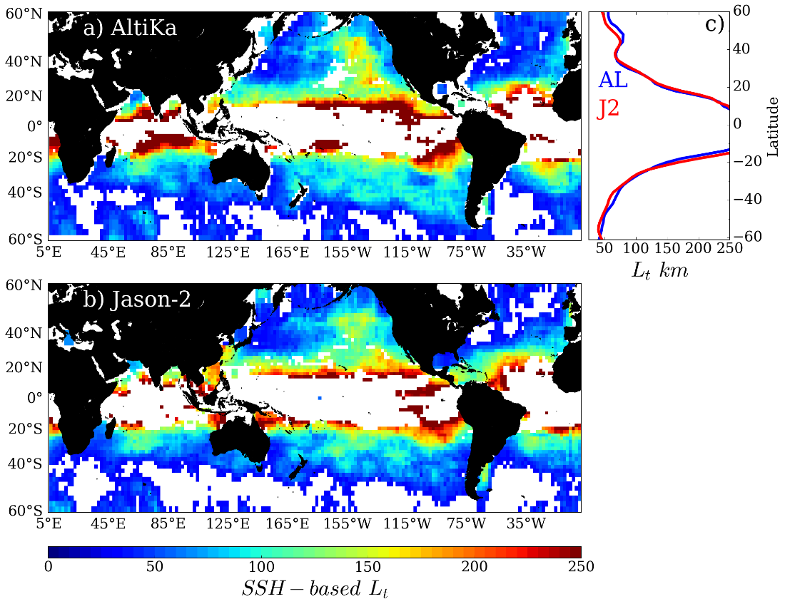
Figure. Transition Scale (Lt) estimates from (a) AltiKa and (b) Jason-2. (c) Zonal averages of (a) and (b). after Vergara et al., in preparation.

- Eddy diagnostics
We plan to investigate metrics on the ocean’s anisotropic structure, velocity, vorticity and strain, 2D energy and momentum fluxes, across the SWOT swaths, and for the multi-mission reconstructed SSH fields. A key component of calculating eddy statistics will be to choose the spatial scales where the balanced motions dominate (see 1), whether a phase-locked internal tide correction has been applied or not. We will investigate the choice of the best smoothing scales for regional analyses of the surface velocity field within the swaths, often above the local error level for SWOT.

- Detection of Fronts and Eddies in SWOT & multi-altimeter data
We aim to explore how the surface expression of fine-scale tracer fronts (SST, ocean color) co-incide or not with the subsurface position and strength of fronts and eddies detected by altimetric SSH. For this, we will perform statistical comparisons in different key regions (including the SWOT CalVal sites and coastal current sites).

- Regional/Coastal analyses

- Alongtrack coastal signal and errors
LEGOS / CTOH already develops, validates and distributes a new alongtrack high resolution coastal altimetry product (20/40 Hz) in certain regions defined in the ESA CCI Sea Level projects (3 zones today on the European coast, the Mediterranean Sea, and in the eastern tropical Atlantic Ocean; 6 in 2020 extending into the north Indian Ocean, SE Asia and Australia). This project is accompanied by studies to define the best possible set of corrections for coastal studies in each region, their uncertainties, and their impact on coastal applications. Today these regions do not include the main areas of SWOT CAL / VAL. We propose to extend these analyses to investigate the alongtrack (and then SWOT) corrections/noise at high resolution in the different SWOT CalVal sites (California, W Mediterranean, New Caledonia, South Tasmania), as part of this project. Although JPL & CNES/CLS will perform these error analyses globally, we will concentrate our activities on the regions where LEGOS has local expertise, and where the errors in certain corrections may vary (eg waves/swell on eastern boundaries ; wet tropospheric corrections in humid tropics or foggy upwelling regions).

- SSH fine-scale coastal composites
In parallel, we will also study the 2D SSH structure in coastal regions and investigate what the new 2D SWOT view should bring, in comparison to the historical 1D alongtrack analyses. SWOT’s 2D swath data can quantify the small-scale spatial SSH patterns of coastal flow around bathymetric or coastline changes, or in response to orographic wind forcing. SWOT’s temporal revisits during the Fast Sampling Phase will allow 3 months of local space-time analysis of the small, rapid coastal processes under the swaths. During the nominal phase of SWOT, the weak temporal sampling will not allow us to fully monitor the evolution of the small, rapid coastal processes, but composites can help us charcterise the local coastal structures (mean or seasonal composites of small-scale structures; wind-orientated composites of eddy generation, etc). We plan to investigate how SWOT can be used in an integrated way with other observation platforms (other altimetry missions, satellite tracer data, and in-situ data) or HR models.

- Coral Reefs
The circulation in and around coral reefs, including the flushing over a tidal cycle, is critical for many biological and chemical applications. We propose a final study on the ability of today’s alongtrack altimeter data (particularly Saral and S3) to observe the SSH changes across coral reefs, and eventually the geostrophic currents close to these reefs. The standard radar signal will be strongly perturbed by the exposed coral at low tide, but will be potentially undisturbed at high tide. This pre-study will be continued with SWOT data in specific regions (New Caledonia, Great Barrier Reef).

C) SWOT science user support

The CTOH, with the support of CNES, aims to provide SWOT science user support and contribute to the SWOT Ocean scientific management and administration.

Selected Team references

Birol, F., M. Cancet, C. Estournel: Aspects of the seasonal variability of the Northern Current (NW Mediterranean Sea) observed by altimetry. J. of Mar. Systems, 10.1016/j.jmarsys.2010.01.005, 2010.
Birol. F and C. Delebecque, 2014: Using high sampling rate (10/20 Hz) altimeter data for the observation of coastal surface currents: A case study over the northwestern Mediterranean Sea, J. Mar. Syst., doi:10.1016/j.jmarsys.2013.07.009, 2014.
Birol, F and F. Niño: Ku and Ka-Band Altimeter Data in the Northwestern Mediterranean Sea. Marine Geodesy no. SARAL/Altika special issue, vol. 38, doi:10.1080/01490419.2015.1034814, 2015.
Birol, F., N. Fuller, F. Lyard, M. Cancet, F. Niño, C. Delebecque, S. Fleury, F. Toublanc, A. Melet and M. Saraceno, F. Léger, 2016. Coastal applications from nadir altimetry: example of the X-TRACK regional products. Advances in Space Research, doi:10.1016/j.asr.2016.11.005.-
Dencausse G, Morrow R, Rogé M, Fleury S (2014) Lateral stirring of large-scale tracer fields by altimetry. Ocean Dyn 64:61–78. doi:10.1007/s10236-013-0671-8
Dufau, C., M. Orsztynowicz, G. Dibarboure, R. Morrow (2016), P.Y. Le Traon. Mesoscale Resolution Capability of altimetry: present & future. J. Geophys. Res. Oceans, 121, 4910–4927, doi:10.1002/2015JC010904
Fu, L-L, D Alsdorf, E Rodriguez, R Morrow, N Mognard, J Lambin, P Vaze and T Lafon (2009) The SWOT (Surface Water and Ocean Topography) Mission: Spaceborne Radar Interferometry for Oceanographic and Hydrological Applications. OCEANOBS’09 White Paper
Fu, LL., E Rodriguez, D Alsdorf, R. Morrow (eds). (2012). SWOT Mission Science document. JPL Publication. https://swot.jpl.nasa.gov/files/swot/SWOT_MSD_1202012.pdf
Gille, S. T., Carranza, M. M., Cambra, R., and Morrow, R.: Wind-induced upwelling in the Kerguelen Plateau region, Biogeosciences, 11, 6389-6400, doi:10.5194/bg-11-6389-2014, 2014.
Jébri, F., F. Birol, B. Zakardjian, J. Bouffard and C. Sammari, 2016: Variability of the surface circulation observed from coastal altimetry over the Tunisian shelf (Central Mediterranean Sea). Journal of Geophysical Research Ocean, doi:10.1002/2016JC011961.
Jébri, F., B. Zakardjian, F. Birol, J. Bouffard and C. Sammari, 2017: Interannual variations of the surface currents and the volume transport in the Central Mediterranean Sea based on coastal altimetry. Journal of Geophysical Research Ocean, doi: 10.1002/2017JC012836.
Morrow R., A Carret, F Birol, F Nino, G Valladeau, F Boy, C Bachelier, B Zakardjian (2017). Observability of fine-scale ocean dynamics in the Northwest Mediterranean Sea. Ocean Sciences 13, 13-29. Doi:10.5194/os-13-13-2017
Morrow, R. D. Blumstein, G. Dibarboure (2018). Fine-scale altimetry and the future SWOT mission. In “New Frontiers in Operational Oceanography” GODAE Ocean View International School Special edition. 815pp, https://doi.org/10.17125/gov2018
Morrow, R., L-L Fu, F Ardhuin, M Benkiran, B Chapron, E Cosme, F D’Ovidio, J. T Farrar, S T. Gille, G Lapeyre, P-Y Le Traon, A Pascual, APonte, B Qiu, N Rascle, C Ubelman^{n}, J Wang, E D. Zaron. (2019) Global observations of fine-scale ocean surface topography with the Surface Water and Ocean Topography (SWOT) Mission. OceanObs2019, Frontiers in Marine Science. DOI: 10.3389/fmars.2019.00232
Pegliasco, C. A. Chaigneau, R. Morrow (2015) Main eddy vertical structures observed in the four major eastern boundary upwelling systems. J. Geophys. Res. Oceans, 120, 6008–6033, doi:10.1002/2015JC010950.
Rogé, M., R. Morrow, G. Dencausse (2015). Altimetric lagrangian advection to reconstruct Pacific Ocean fine scale surface tracer fields. Ocean Dynamics 65:1249–1268. DOI 10.1007/s10236-015-0872-4.
Rogé, M., Morrow R , Ubelmann C and Dibarboure G (2017). Using a dynamical advection to reconstruct a part of the SSH evolution in the context of SWOT, application to the Mediterranean Sea. Ocean Dynamics (2017). Doi: 10.1007/s10236-017-1073-0.
Serazin, G. et al (2019). Scale-dependent analysis of in situ observations in the mesoscale to submesoscale range around New Caledonia" J. Phys. Oceanogr., in press (JPO-D-19-0251)
Tchilibou, M., Gourdeau, L., Morrow, R., Serazin, G., Djath, B., and Lyard, F.: Spectral signatures of the tropical Pacific dynamics from model and altimetry: A focus on the meso/submesoscale range, Ocean Sci. Discuss., https://doi.org/10.5194/os-2018-49, 2018.
Ubelmann and Fu, 2014
Vergara, O., R Morrow, M.I. Pujol, G Dibarboure, C Ubelmann. Revised global wavenumber spectra from recent altimeter observations. J. Geophys. Res. doi:10.1029/2018JC014844

